# **PRACTICAL NO : 23**

**Aim : Write a program to Display Hello World using ReactJS :**

**Code :**

**App.js**

import logo from './logo.svg';

import './App.css';

function App() {

return (

<div className="App">

<header className="App-header">

<img src={logo} className="App-logo" alt="logo" />

<p>

Hello World ! My name is Sakib.

</p>

<a

className="App-link"

href="https://reactjs.org"

target="_blank"

rel="noopener noreferrer"

>

Learn React

</a>

</header>

</div>

);

}

export default App;

**Output :**

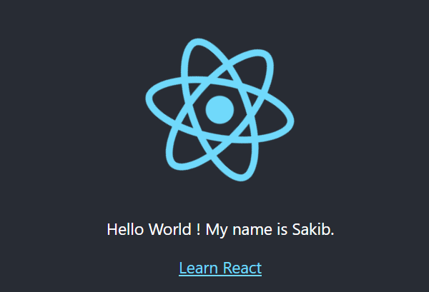

# **PRACTICAL NO : 24**

**Aim : Create an application in ReactJS to implement component life cycle**

**Code :**

**App.js**

import logo from './logo.svg';

import './App.css';

import React, {useState, useEffect} from 'react';

const LifecycleCompenent= () => {

const[count, setCount]= useState(0);

const[message, setMessage]= useState('Hello World !');

// Equivalent to componentDidMount ,componentDidUpdate , componentWillUnmount

useEffect(() => {

//This function will run once when the component mounts(initial render)

console.log('Component mounted !');

//This function will run once when the componentWillUnmount

return () => {

console.log('Component will unmount !');

};

}, []); //Empty dependency array means this run only once on mount

useEffect(() => {

//This function will run every time the count changes (update phase)

console.log('Count updated to ${count}');

} ,[count]); //This run only when 'count' changes

const handleClick= () => {

setCount(count + 1); //Increment Count

};

const handleMessageChange= () => {

setMessage('Message has been changed'); //Update Message

};

return (

<div>

<h1> React Component Lifecycle Example</h1>

<p> Message : {message} </p>

<p> Count : {count}</p>

<button onClick={handleClick}> Increment Count</button>

<button onClick={handleMessageChange}> Change Message</button>

</div>

);

};

const App=() => {

return (

<div className='App'>

<h2>React Component Lifecycle Component</h2>

<LifecycleCompenent/>

</div>

);

};

export default App;

**Output :**

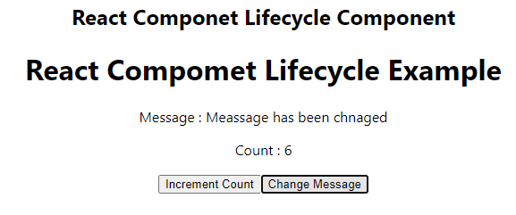

# **PRACTICAL NO : 25**

**Aim: Create an application to implement class and functional component in ReactJS**

**Code :**

**Class Component**

**MyClassComponet.js**

import React, {Component} from 'react';

class MyClassComponent extends Component {

constructor(props){

super(props);

this.state={

message :'Hello , Welcome to React Class Component ',

counter: 0,

};

}

incrementCounter=()=> {

this.setState((prevState)=> ({

counter:prevState.counter+1,

}));

};

render(){

return(

<div style={{textAlign:'center' ,marginTop:'50px'}}>

<h1>{this.state.message}</h1>

<p>Counter :{this.state.counter}</p>

<button onClick={this.incrementCounter} style={{padding:'10 px 20 px', fontSize:'16px'}}>

IncrementCounter

</button>

</div>

);

}

}

export default MyClassComponent;

**App.js**

import logo from './logo.svg';

import './App.css';

import MyClassComponent from './MyClassComponent';

function App() {

return (

<div>

<MyClassComponent/ >

</div>

);

}

export default App;

**Output :**

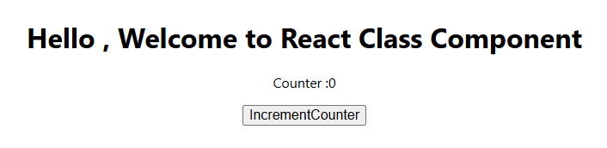

# **PRACTICAL NO : 26**

**Aim: Create an application to implement functional component in ReactJS**

**CODE :**

**app.js**

import './App.css';

import React, {useState} from 'react';

const AddTwoNumbers=()=> {

const [num1, setNum1] = useState('');

const [num2, setNum2] = useState('');

const [sum, setSum] = useState(null);

const handleAddition= () =>{

const result =parseFloat(num1) +parseFloat(num2);

setSum(result);

};

return (

<div style={{textAlign:'center',marginTop:'50px'}}>

<h1> Add Two Numbers</h1>

<div style ={{ marginBottom:'20px'}}>

<input type="number" placeholder='Enter first number'

value={num1}

onChange={(e) => setNum1(e.target.value)}

style={{marginRight:'10 px' ,padding:'5 px'}} />

<input type="number" placeholder='Enter second number'

value={num2}

onChange={(e) => setNum2(e.target.value)}

style={{marginRight:'10 px' ,padding:'5 px'}} />

<button onClick={handleAddition} style={{padding: '5px 10 px'}}>Add</button>

{sum!==null && <h2> Result : {sum}</h2>}

</div>

</div>

);

};

export default AddTwoNumbers;

**Output :**

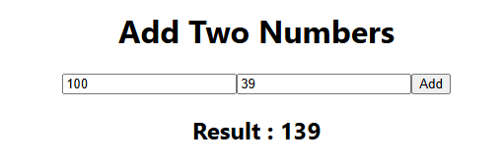

# **PRACTICAL NO : 27**

**Aim :Create an application in ReactJS import and export the files (components)**

**Code:**

**FileUploader.js**

import React, { useState } from "react";

const FileUploader = () => {

const [fileContent, setFileContent] = useState(""); // Declare useState correctly

const handleFileUpload = (e) => {

const file = e.target.files[0];

const reader = new FileReader();

reader.onload = (event) => {

setFileContent(event.target.result); // Correctly set file content

};

if (file) reader.readAsText(file); // Read file as text

};

return (

<div>

<h3>Upload a File</h3>

<input type="file" onChange={handleFileUpload} />

{fileContent && ( // Conditionally render file content

<div>

<h4>File Content:</h4>

<textarea value={fileContent} readOnly rows="10" cols="50" />

</div>

)}

</div>

);

};

export default FileUploader;

**FiledDownlaoder.js**

import React from "react";

const FileDownloader = () => {

const handleDownload = () => {

const content = "This is some sample text for the file.";

const blob = new Blob([content], { type: "text/plain" });

const url = URL.createObjectURL(blob);

const link = document.createElement("a");

link.href = url;

link.download = "sample.txt";

link.click();

URL.revokeObjectURL(url);

};

return (

<div>

<h3>Download a File </h3>

<button onClick={handleDownload}>Download</button>

</div>

);

};

export default FileDownloader;

**App.js**

import React from "react";

import FileDownloader from "./components/FileDownloader.js";

import FileUploader from "./components/FileUploader.js";

function App() {

return (

<div style={{ textAlign: "center", margin: "20px" }}>

<h1>React File Import/Export</h1>

<FileUploader />

<FileDownloader />

</div>

);

}

export default App;

**Output :**

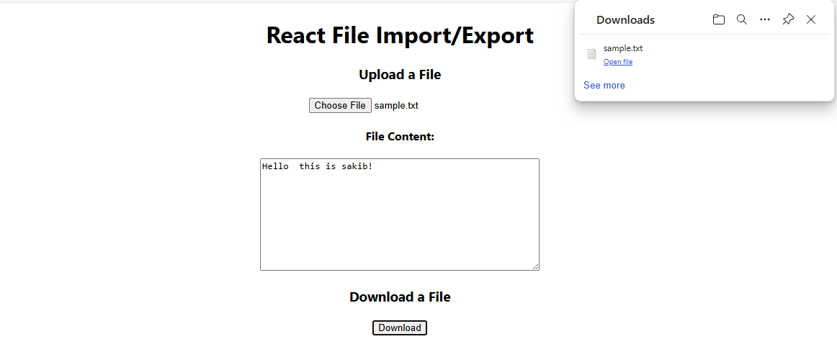

# **PRACTICAL NO : 28**

**Aim :Create an application to increment and decrement counter using state.**

**Code:**

**App.js**

import './App.css';

import React, { useState } from 'react';

const Counter = () => {

const [count, setCount] = useState(0);

return (

<div>

<h1>Count: {count}</h1>

<button onClick={() => setCount(count + 1)}>Increment</button>

<button onClick={() => setCount(count - 1)}>Decrement</button>

</div>

);

};

export default Counter;

**Output :**

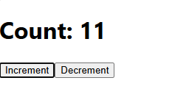

# **PRACTICAL NO : 29**

**Aim : Create an application to display your name using prop.**

**Code :**

**App.js**

const Greeting = ({ name }) => {

return <h1>Hello, {name}!</h1>;

};

const App = () => {

return (

<div>

<Greeting name="Alice" />

<Greeting name="Bob" />

</div>

);

};

export default App;

**Output :**

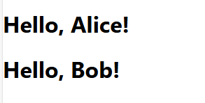

# **PRACTICAL NO : 30**

**Aim: Create an application to implement To-Do task.**

**Code:**

**App.js**

import React, { useState } from 'react';

import TaskList from './TaskList';

const App = () => {

const [tasks, setTasks] = useState([]); // State to manage tasks

const [taskInput, setTaskInput] = useState(''); // State for input field

const handleAddTask = () => {

if (taskInput.trim() !== '') {

setTasks([...tasks, taskInput]); // Add new task to the list

setTaskInput(''); // Clear input field

} };

return (

<div style={{ padding: '20px' }}>

<h1>To-Do List</h1>

<div>

<input

type="text"

value={taskInput}

onChange={(e) => setTaskInput(e.target.value)}

placeholder="Enter a new task"

style={{ padding: '10px', width: '300px', marginRight: '10px' }}

/>

<button onClick={handleAddTask} style={{ padding: '10px' }}>

Add Task

</button>

</div>

<TaskList tasks={tasks} />

</div>

);

};

export default App;

**Tasklist.js - Child Component**

import React from 'react';

const TaskList = ({ tasks }) => {

return (

<div style={{ marginTop: '20px' }}>

<h2>Your Tasks</h2>

{tasks.length === 0 ? (

<p>No tasks added yet.</p>

) : (

<ul>

{tasks.map((task, index) => (

<li key={index} style={{ marginBottom: '10px' }}>

{task}

</li>

))}

</ul>

)}

</div>

);

};

export default TaskList;

**Output:**

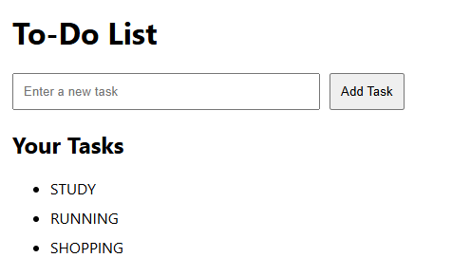

**PRACTICAL NO : 31**

**Aim: Create an application in ReactJS to use DOM events- onChange.**

**Code:**

**App.js**

import React , {useState} from "react";

function ToggleMessage() {

const[isChecked , setIsChecked]= useState(false); // State to track checkbox toggle

const handleCheckboxChange= (event) => {

setIsChecked(event.target.checked); // Update state when checkbox is toggled

};

return (

<div style={{margin:"20 px", textAlign:"center"}}>

<h3> Show/Hide Message</h3>

<label>

<input type="checkbox" onChange={handleCheckboxChange} // Event handler for checkbox

style={{marginRight:"10 px"}}

/>

</label>

<div style={{marginTop:"20 px"}}>

{isChecked && <p style={{color:"green"}}> Hello , this is your Message !</p>}

</div>

</div>

)

}

export default ToggleMessage;

**Output**



# 

# 

# 

# 

# 

# **PRACTICAL NO : 32**

**Aim : Write a program that tracks the changes in an input field and displays the entered text in real-time using onChange DOM event.**

**Code:**

**App.js**

import React, {useState} from "react";

function InputTracker() {

const[text, setText]=useState(""); // State to store the input value

const handleChange=(event) => {

setText(event.target.value); // Update the state with input value

};

return (

<div style={{margin:"20 px"}}>

<h3>Input Field Change Tracker</h3>

<input type="text" placeholder="Type something here.." value={text} onChange={handleChange} // Event handler for onChange

style={{ padding :"8 px", border:"1 px solid #ccc" , borderRadius:"4px" ,width:"300px",}} />

<p style={{marginTop:"10 px"}} >You typed : {text} </p>

</div>

);

}

export default InputTracker;

**Output :**

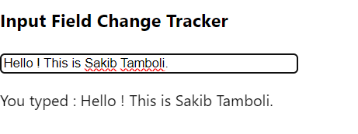

# **PRACTICAL NO : 33**

**Aim : Create an application in ReactJS to use DOM events- onKeyUp.**

**Code:**

**App.js**

// OnKeyUP

import React, {useState} from "react";

function KeyCodeDisplay() {

const [keyCode, setKeyCode] = useState("");

const handleKeyUp=(e) => {

setKeyCode(`Key Code : ${e.keyCode}`);

};

return (

<div>

<input type="text" onKeyUp={handleKeyUp} placeholder="Press a key.." />

<p>{keyCode}</p>

</div>

)

}

export default KeyCodeDisplay;

**Output :**

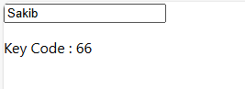

# **PRACTICAL NO : 34**

**Aim: Write a Program to Counts words as they are typed using onKeyUp event.**

**Code:**

**App.js**

// OnKeyUP

import React, {useState} from "react";

function WordCount() {

const [wordCount, setWordCount] = useState(0);

const handleKeyUp=(e) => {

const words=e.target.value.trim().split(/\s+/);

setWordCount(words[0]===""?0: words.length);

};

return (

<div>

<textarea onKeyUp={handleKeyUp}

placeholder="Enter text here" />

<p> Word Count :{wordCount}</p>

</div>

)

}

export default WordCount;

**Output :**

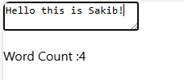

# **PRACTICAL NO : 35**

**Aim : Write a Program to implement validation logic for an email field using onBlur event.**

**Code:**

**App.js**

// OnKeyUP

import React, {useState} from "react";

function ValidateOnBlur() {

const [error, setError] = useState("");

const handleBlur=(e) => {

const email=e.target.value;

if(!email.includes("@")) {

setError("Invalid email");

} else {

setError("");

}

};

return (

<div>

<input type ="text"

onBlur={handleBlur}

placeholder="Enter your email" />

{error && <p style={{color:"red"}}>{error}</p>}

</div>

);

}

export default ValidateOnBlur;

**Output:**

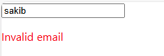

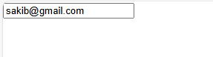

# 

# 

# 

# 

# 

# 

# **PRACTICAL NO : 36**

**Aim: Create an application in ReactJS form and add client validation.**

**Code:**

**App.js**

import React ,{useState} from "react";

function BasicFormValidation () {

const[formData, setFormData]=useState({name:"", email:""});

const[errors,setErrors]=useState({});

const handleChange=(e) => {

const {name, value} =e.target;

setFormData({...formData,[name]:value});

};

const validate=() => {

const newErrors={} ;

if(!formData.name)newErrors.name="Name is required";

if(!formData.email)newErrors.email="Email is required";

else if(!/\S+@\S+\.\S+/.test(formData.email))

newErrors.email="Email is invalid";

setErrors(newErrors);

return Object.keys(newErrors).length===0;

};

const handleSubmit=(e) => {

e.preventDefault();

if(validate()) {

alert("Form submitted successfully");

}

};

return(

<form onSubmit={handleSubmit}>

<div>

<label> Name: </label>

<input type="text"

name="name"

value={formData.name}

onChange={handleChange}

/>

{errors.name && <p style={{color:"red"}}>{errors.name}</p> }

</div>

<div>

<label>Email:</label>

<input type="text"

name="email"

value={formData.email}

onChange={handleChange}

/>

{errors.email && <p style={{color:"red"}}>{errors.email} </p> }

</div>

<button type="submit" >Submit</button>

</form>

);

}

export default BasicFormValidation;

**Output :**

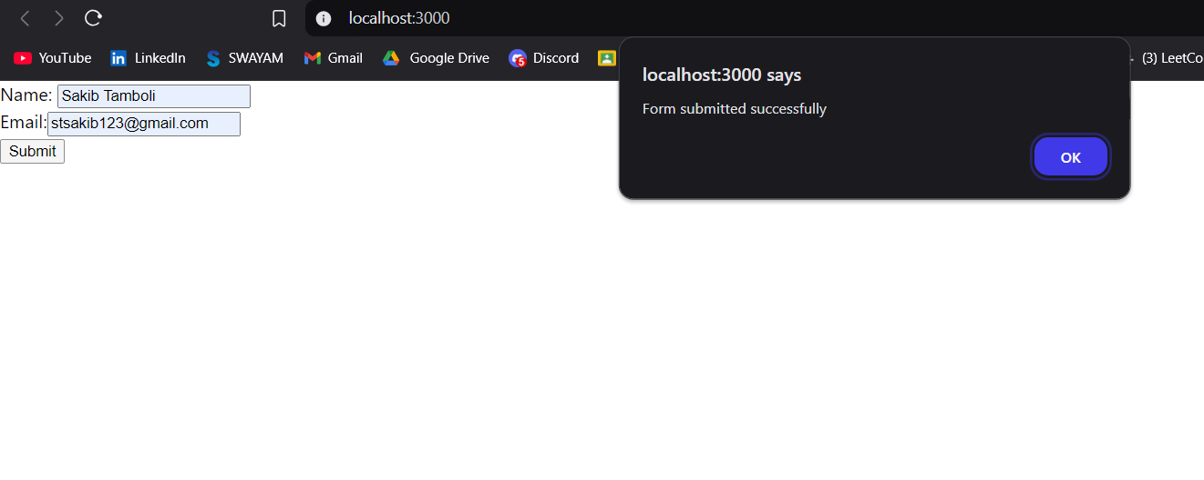

# 

# 

# 

# 

# 

# 

# 

# **PRACTICAL NO : 37**

**Aim : Write a Program to implement useEffect hook.**

**Code :**

**App.js**

import React, { useEffect } from 'react';

function SimpleComponent() {

useEffect(() => {

console.log('Component mounted!');

}, []); // Empty dependency array ensures this runs only once on mount

return <div>Hello, World!</div>;

}

export default SimpleComponent;

**Output :**



**Practical No :38**

**Aim :Create SPA using React Router.**

**Code:**

**App.js**

import React from "react";

import { BrowserRouter as Router, Routes, Route, Link } from "react-router-dom"; import Home from "./components/Home";

import About from "./components/About";

import Contact from "./components/Contact";

const App = () => {

return (

<Router>

<nav>

<ul>

<li>

<Link to="/">Home</Link>

</li>

<li>

<Link to="/about">About</Link>

</li>

<li>

<Link to="/contact">Contact</Link>

</li>

</ul>

</nav>

<Routes>

<Route path="/" element={<Home />} />

<Route path="/about" element={<About />} />

<Route path="/contact" element={<Contact />} />

</Routes>

</Router>

);

};

export default App;

**About.js**

import React from "react";

const About=() => {

return <h1> About Us</h1>

};

export default About;

**Home.js**

import React from "react";

const Home=() => {

return <h1> Welcome to Home Page ! This is Sakib .</h1>

};

export default Home;

**Contact.js**

import React from "react";

const Contact=() => {

return <h1> Contact Us</h1>

};

export default Contact;

**Output :**





